INVADUS, CHAPTER 20
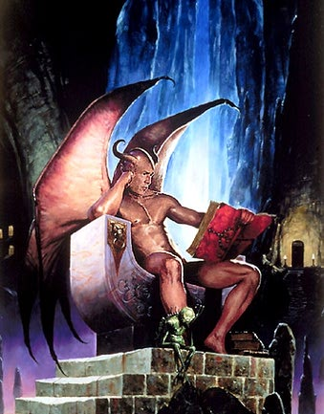

THE BUSH COMMANDMENTS!
http://www.rense.com/1.imagesG/bushdevil1.jpg

1 And George spake all these words, saying,
2 I am GEORGE IV, which have brought thee into the land of Iraq, into the home of Saddam.
3 Thou shalt have no other gods except me.
4 Thou shalt make unto thee my graven image, or any corporation of any thing that is in heaven above, or that is in the earth beneath, or that is in the water under the earth :
5 Thou shalt bow down thyself to them, and serve them : for I GEORGE IV am a jealous god, visiting iniquity of fathers upon children unto the last generation of them that hate me ;
6 And shewing mercy unto hordes of them that love me, and keep my commandments.
7 Thou shalt not take the name of GEORGE IV in vain ; for GEORGE will not hold him guiltless that taketh his name in vain.
8 Faggeddaabboouutt the Sabbath day, and keep on workin’.
9 Every day shalt thou labour, and do all my work :
10 But the seventh day is the Sabbath of GEORGE IV : in it I shalt not do any work, I, nor my son, nor my daughter, my toy boy, nor my whore, nor my cattle, nor my old pal that is within my gates :
11 For in six days GEORGE works hard on hard work : wherefore GEORGE rests the Sabbath day, and enjoys it.
12 Honour my father and my mother : that my days may be long upon the land which GEORGE IV giveth thee.
13 Thou shalt kill others, not me.
14 Thou shalt commit adultery, with me.
15 Thou shalt steal, for me.
16 Thou shalt bear false witness against thy neighbour, with me.
17 Thou shalt covet thy neighbour’s house, thou shalt covet thy neighbour’s wife, his boy toy, his whore, his ox, his ass, and any thing that is thy neighbour’s.

